Chapter 17, Problem 76.

A periodic signal given by v_{s}(t) = 10V for 0<t<1 and 0V for 1<t<2 is applied to the high pass filter in Fig. 17.87. Determine the value of R such that the output signal v_{o}(t) has an average power of least 70 percent of the average power of the input signal.

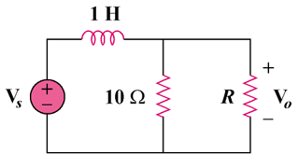

Figure 17.87
For Prob. 17.76

